**How to Install Library ?**

**What are Arduino Libraries ?**

[Libraries](https://www.arduino.cc/en/Reference/Libraries)are a collection of code that makes it easy for you to connect to a sensor,display, module, etc.

For example, the built-in LiquidCrystal library makes it easy to talk to character LCD displays. There are hundreds of additional libraries available on the Internet for download.

The built-in libraries and some of these additional libraries are listed in the reference. To use the additional libraries, you will need to install them.

Here we will introduce the most simple way for you to add libraries .

**Step 1:** After downloading well the Arduino IDE, you can right-click the icon of Arduino IDE.  
Find the option "Open file location" shown as below.

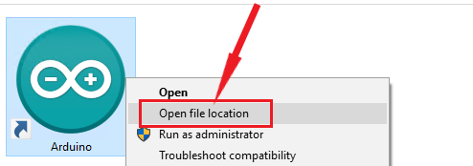

**Step 2:** Find out libraries folder, the library file of Arduino.

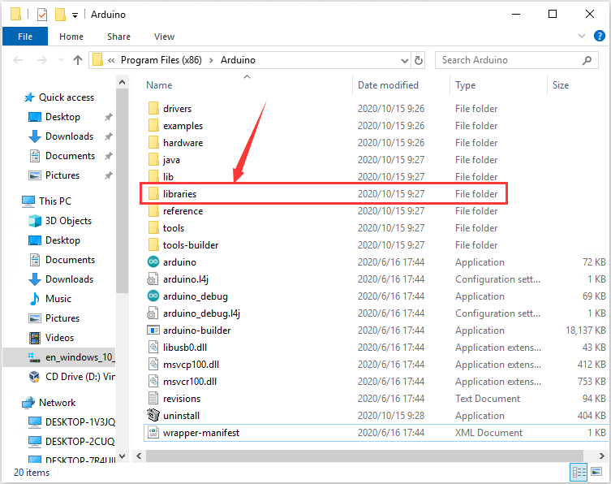

**Step 3：**Next to find out the“libraries”folder of frog robot(seen in the link: https://fs.keyestudio.com/KS0446)

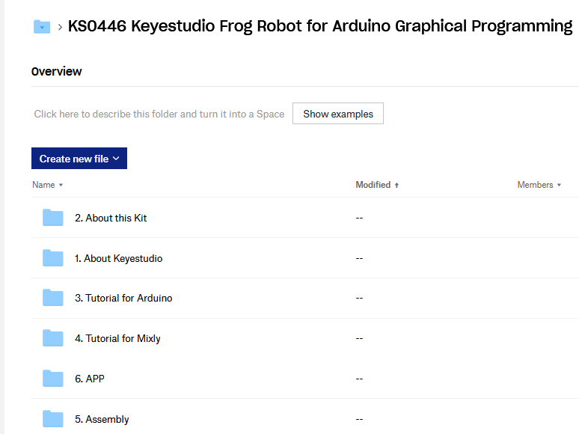

Click and tap “Libraries”

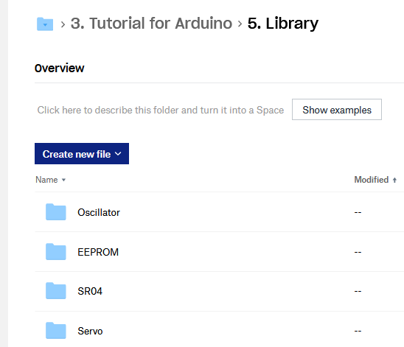

Copy the above libraries into libraries of Arduino IDE.

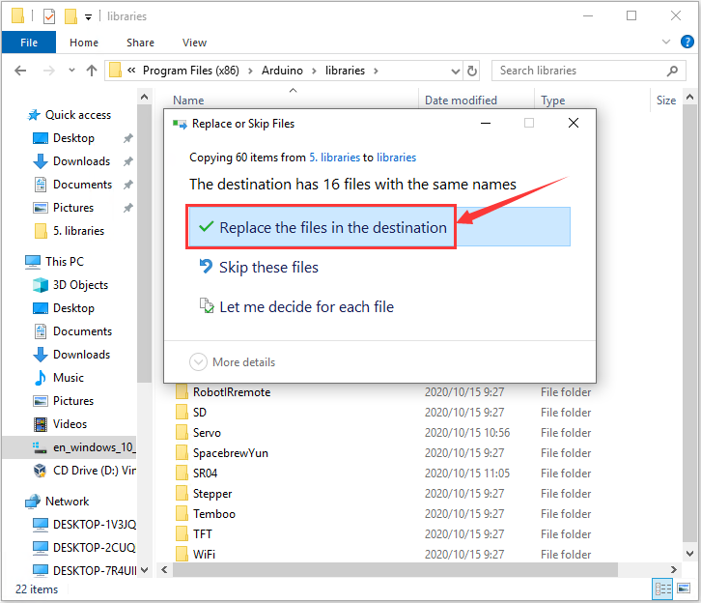  
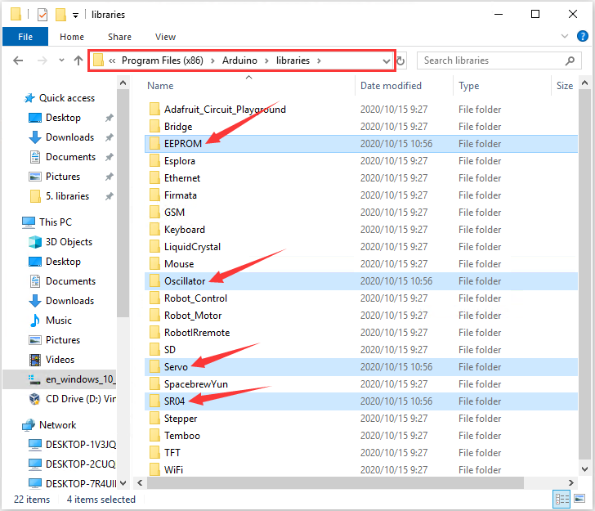

The libraries of frog robot are well installed.